

**Think Science! Newsletter 3**

**This month: Processing and analysing**

**Recording results**

Student teams will need to record measurements taken and their observations during their investigation. Using a table is the best way of recording these data. The table needs to be set up in a particular way, as outlined below. The table should include **what they are changing (independent variable)** in the left-hand column, **what they are measuring (dependant variable)** in the next column(s) including the units of measurement (e.g. cm, grams etc.). We recommend that teams conduct more than one trial for each changed variable and columns for each trial should be included in the table. Secondary students should also include calculated averages in the table.

|  |  |  |  |  |
| --- | --- | --- | --- | --- |
| **What is being changed** | **What is being measured** (and units) | | | Observations |
| Trial 1 | Trial 2 | Trial 3 |
|  |  |  |  |  |
|  |  |  |  |  |

**Processing results**

After results have been collected, teams will need to process them to look for any patterns and relationships between data. One of the best ways to do this is by graphing the results.

Two common types of graphs used for presenting information in science investigations are column graphs and line graphs. Which one is most suitable to use depends on the type of data collected in the investigation.

When **data is in groups or categories and words are used to describe them, and only the dependent variable is a number, the best graph to use is a column graph**. Here data is represented by columns or rectangles of equal width (which are not touching), and the height of each column corresponds to the value it represents. An example of a column graph is shown below, for an investigation comparing the effect of wing tip on the distance travelled by paper planes.

A **line graph is suitable to use when both the dependent and independent variables involve numbers (continuous data)** and is commonly used when comparing changes over time. In this type of graph**,** individual points are plotted and a line is drawn to connect the points.An example of a line graph is shown below, for an investigation comparing the temperature of a white and black box.

The labelling and layout for graphs used in science investigations is as follows:

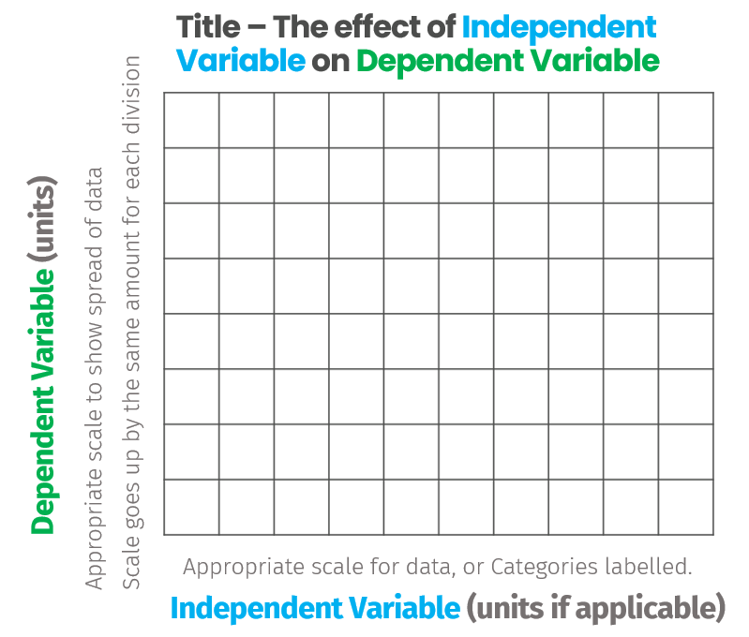

Teams may choose to plot data for each trial (separately) on a column graph. This will help students to see differences between trials and identify any anomalies in their data. For a line graph, teams should plot the average values of trials.

For *Think Science!*, tables and graphs can be hand drawn or created digitally. Graph paper will be helpful for hand-drawn graphs. Clear photos or digital images of data tables and graphs must be included in the video presentation submitted. These images must be large enough for the viewer to be able to read all text and numbers and displayed for sufficient time to view.

Examples of a column graph (left) and line graph (right):

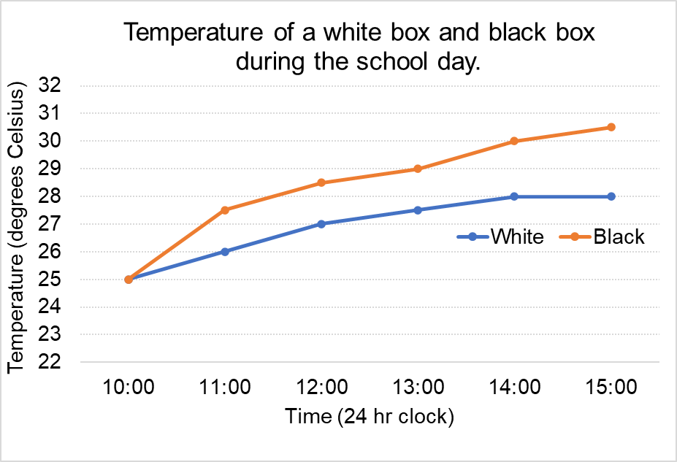

The effect of wingtip on distance travelled by the paper plane.

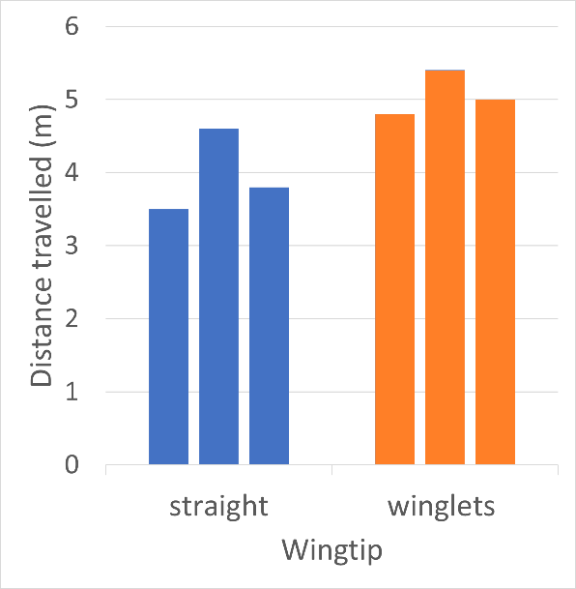

**Analysing results**

After graphs have been constructed, students should identify and describe any patterns or trends in their graph/s. For example, using a paper plane activity – if all the planes flew a similar distance they could say “The planes with straight wings all flew around 4 metres from the launch line”. If there was a substantial difference in trial results they could look at the smallest and largest distances they flew and say “The planes with straight wings all flew between 3.5 and 4.6 metres from the launch line.”

Secondary students should also point out any results which appear to be inconsistent or anomalous.

**The next newsletter will focus on ‘Evaluating’- the fourth science inquiry skill. It will cover how students can reflect on their results in greater depth and formulate a conclusion.**

