Senior Physics
Online Learning Session workbook

ANSTO’s Physics Online Learning Session addresses science understanding from:

Australian Curriculum Physics

Unit 1: Thermal, nuclear and electrical physics, specifically the section ‘Ionising radiation and nuclear reactions’ and

Unit 4: Revolutions in modern physics, specifically Special relativity – Nuclear reactors and The Standard Model - Particle accelerators

- NSW Physics Stage 6 Syllabus for the Australian Curriculum
Module 8: From the Universe to the Atom, specifically the section ‘Properties of the Nucleus’, Inquiry question: How can the energy of the atomic nucleus be harnessed?

During the online learning session, students will:
- investigate the properties of the three main types of radiation (alpha, beta and gamma)
- collect data during a demonstration of a radiation experiment, using low level radioactive sources and radiation detection equipment.
- explore why some atoms are radioactive
- understand how half-life of a radioisotope is determined experimentally
- understand the operation and uses of OPAL (Open Pool Australian Lightwater) Research Reactor
- explore a model of the process of nuclear fission
- explore an analogy of binding energy
- understand the operation of ANSTO’s tandem particle accelerators and their uses

During the online learning session your Education Officer will provide students with information from which they will be required to select and process the appropriate material to complete the activities and answer the questions.

Students will also need further time after the presentation to complete some of the activities.

Investigating the properties of alpha, beta and gamma radiation
- View the demonstration and record the radioactivity measured by the scintillation counter in each of the following situations.

Source | Radioactivity (counts per second)
 | No cover | Paper | Aluminium | Lead
A
B
C

- Use the data you have recorded to identify the type of radiation produced by each source. Justify your choice.

Source | Type of radiation | Justification: Why do you think it is this radiation?
A
B
C

- Gamma emission usually accompanies alpha or beta decay. Which other form of radiation do you think is being emitted from the gamma source? Give a reason for your answer.
…………………………………………………………………………………………………………………………………………………………………………………………………………………………………………………………………………………………………………………………

Investigating radiation and distance from the source
The Education Officer will demonstrate how the radiation count changes with distance from a source.
Record the data in the table below.

Use the data to sketch a curve on the grid below to show how the radiation count changes with distance from a source.

OPAL research reactor

Label the diagram and complete the table below:

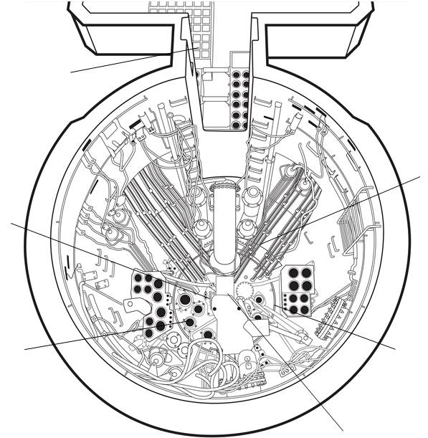

Material | Reactor component | Function
Uranium
enriched with 19.75 % U-235
Heavy water
made with deuterium $({}_{1}^{2}{H)}$
Light water
made with hydrogen $({}_{1}^{1}{H)}$
Hafnium
encased in stainless steel

Modelling Fission

During the presentation you will view an animation of the fission process. This animation can also be found at a video - OPAL research reactor animation - YouTube (from 0.45 – 1.21)
After viewing the animation, answer the questions below:

What does this animation model show about the process of nuclear fission in our OPAL nuclear reactor?
…………………………………………………………………………………………………………………………………………………………………………………………………………………………………………………………………………………………………………………………
…………………………………………………………………………………………………………………………………………………………….
Does it simulate a controlled or uncontrolled fission reaction?
…………………………………………………………………………………………………………………………………………………………….
What are the limitations of this model of nuclear fission for our OPAL nuclear reactor? What is missing from this model?
…………………………………………………………………………………………………………………………………………………………………………………………………………………………………………………………………………………………………………………………
…………………………………………………………………………………………………………………………………………………………….
Describe how the fission reaction is controlled in the OPAL reactor.
…………………………………………………………………………………………………………………………………………………………………………………………………………………………………………………………………………………………………………………………
…………………………………………………………………………………………………………………………………………………………….
Account for the release of energy in the fission process.
…………………………………………………………………………………………………………………………………………………………………………………………………………………………………………………………………………………………………………………………
…………………………………………………………………………………………………………………………………………………………….
How is the fission process started for the very first time in the OPAL reactor (or after it has been shut down for a considerable time)?
…………………………………………………………………………………………………………………………………………………………………………………………………………………………………………………………………………………………………………………………
…………………………………………………………………………………………………………………………………………………………….

Binding Energy analogy

In this analogy magnets, which have their north poles covered with Velcro, are compared to positively charged protons in the nucleus.
- a. Describe what happens when the north poles of the magnets are brought towards
each other.

…………………………………………………………………………………………………………………………………………………………………………………………………………………………………………………………………………………………………………………………
b. Name the force that is causing this effect. ……………………………………………………………………………………………………………………………………………………………

- Describe what happens when the north poles of the magnets are brought very, very close together so that the Velcro ends touch.

…………………………………………………………………………………………………………………………………………………………………………………………………………………………………………………………………………………………………………………………
- What fundamental force do you think is represented by the Velcro? Give a reason for your answer.

…………………………………………………………………………………………………………………………………………………………………………………………………………………………………………………………………………………………………………………………
- What is the name given to the energy you need to add and pull the protons (magnets) apart to separate them?

……………………………………………………………………………………………………………………………………………………………
- Identify one limitation of this analogy.

…………………………………………………………………………………………………………………………………………………………………………………………………………………………………………………………………………………………………………………………

- Complete the following table to summarise the two main forces operating in the nucleus:

Force | Nucleons between which the force acts | Distance over which force acts
Electromagnetic
Strong nuclear

Nuclear Fission and Fusion

Comment on the mass of a nucleus when it is compared to the mass of the individual nucleons that make up that nucleus.
…………………………………………………………………………………………………………………………………………………………………………………………………………………………………………………………………………………………………………………………
……………………………………………………………………………………………………………………………………………………………

This graph is very important and shows the Binding Energy per nucleon for atoms of different nuclear size.
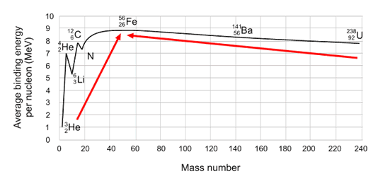
Source: Radioactivity | ARPANSA

On the diagram above:
- indicate the most stable isotope on the graph. Comment on the mass of the nucleons in the nucleus of this isotope.
…………………………………………………………………………………………………………………………………………………………………………………………………………………………………………………………………………………………………………………………I

- indicate the energy that is released by fission and the energy that is released by fusion. Compare these energies.

……………………………………………………………………………………………………………………………………………………………
…………………………………………………………………………………………………………………………………………………………………………………………………………………………………………………………………………………………………………………………

Centre for Accelerator Science

- a) Choose from the following list to label the parts of the tandem accelerator
shown in the diagram below.
positive high voltage terminal, steel pressure tank, pelletron charging chain, evacuated accelerator beam tube, stripping chamber, equipotential rings, magnet.
- Indicate the flow direction and charge of the ions ( ) on the diagram.

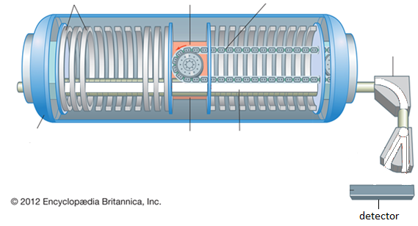

In the tandem accelerator, what is the purpose of each of the following:

electric field
magnetic field

Further Notes

Use the space below for any further notes you wish to take down during the presentation and to record any question you may have. The Education Officer will allocate 10 minutes at the end of the presentation for questions.
………………………………………………………………………………………………………………………………………………………………………………………………………………………………………………………………………………………………………………………………………………………………………………………………………………………………………………………………………
………………………………………………………………………………………………………………………………………………………………………………………………………………………………………………………………………………………………………………………………………………………………………………………………………………………………………………………………………
………………………………………………………………………………………………………………………………………………………………………………………………………………………………………………………………………………………………………………………………………………………………………………………………………………………………………………………………………
………………………………………………………………………………………………………………………………………………………………………………………………………………………………………………………………………………………………………………………………………………………………………………………………………………………………………………………………………
………………………………………………………………………………………………………………………………………………………………………………………………………………………………………………………………………………………………………………………………………………………………………………………………………………………………………………………………………
………………………………………………………………………………………………………………………………………………………………………………………………………………………………………………………………………………………………………………………………………………………………………………………………………………………………………………………………………
………………………………………………………………………………………………………………………………………………………………………………………………………………………………………………………………………………………………………………………………………………………………………………………………………………………………………………………………………
………………………………………………………………………………………………………………………………………………………………………………………………………………………………………………………………………………………………………………………………………………………………………………………………………………………………………………………………………

Post Presentation Activities
Question 1: Radioactive Decay
During the presentation you viewed a video showing how the activity of a radiopharmaceutical was measured over time using a dose calibrator. The data shown in the table below was recorded for a radiopharmaceutical of the radioisotope technetium-99m.
On the grid below, plot the data and use your graph to determine the half-life of technetium-99m.

The radioactive decay of technetium-99m
Time  (hours) | Activity (Megabequerel, MBq)
0 | 1250
0.25 | 1215
0.5 | 1180
0.75 | 1146
1 | 1114
2 | 992
4 | 788
24 | 78

Half-life of technetium-99m ……………………………………………….
Question 2: Radioactive Decay Law
The following equation, known as the radioactive decay law, allows you to quantitatively predict the amount of a radioactive sample that still remains and has not yet decayed after a time t, where
N_{t} = number of radioactive nuclei present at time t, and N₀ = the initial number of radioactive nuclei present (that is, at t = 0)
N_{t} = N₀e^{-λt}
The number of radioactive nuclei present at time t (N_{t}) is proportional to the level of radioactivity of the source. Hence the radioactive decay law can also be represented by
A_{t} = A₀e^{-λt}
where λ = ln(2)
t_{1/2}
where A_{t} = the activity of the sample at time t,
A₀ = the initial activity of the sample that is the activity at t = 0,
λ = decay constant,
t_{1/2} = time for half the radioactive amount to decay,
ln 2 (the natural log of 2) equals 0.693.

- For the radionuclide technetium-99m, use the table on the previous page to state the activity (A_{t}) after the number of stated hours in the table below to calculate the half-life of the technetium-99m.

Number of hours (x) | Initial activity  (A_{o}) | Activity after x hours (A_{t}) | calculated half life
1
4

- Compare the values of the half-life determined for each of the number of hours. Comment on the accuracy of the values.

…………………………………………………………………………………………………………………………………………………………………………………………………………………………………………………………………………………………………………………………

- How might a more accurate value be determined?

………………………………………………………………………………………………………………………………………………………………………………………………………………………………………………………………………………………………………………………….
…………………………………………………………………………………………………………………………………………………………………………………………………………………………………………………………………………………………………………………………

Question 3: Half life
- The half-life of the isotope U-238 is 4.51 x 10⁹ years. The age of the Earth is estimated to be about 4.6 x 10⁹ years. Based on this, predict what proportion, quoted as a percentage, of this isotope of uranium would be found on Earth today compared to when the Earth first formed (HINT: determine N_{t}/N₀ x 100 %).

………………………………………………………………………………………………………………………………………………………………………………………………………………………………………………………………………………………………………………………………………………………………………………………………………………………………………………………………………
………………………………………………………………………………………………………………………………………………………………………………………………………………………………………………………………………………………………………………………………………………………………………………………………………………………………………………………………………

- Carbon-14 is a naturally occurring isotope of carbon that is radioactive. All living things absorb carbon from the environment while they are alive, and then stop taking it in when they die. By analysing the carbon found in ancient remains derived from once living things, the ratio of C-14 to other isotopes of carbon (C-12 or C-13) in the sample can reveal the age of an artefact up to 50,000 years old. Carbon-14 has a half-life of about 5,730 years.

An ancient wooden artefact from a human settlement contains about 12.5% of the C-14 that would be expected if it were alive in the environment today. Based on this result, calculate an approximate age for the ancient artefact.

………………………………………………………………………………………………………………………………………………………………………………………………………………………………………………………………………………………………………………………………………………………………………………………………………………………………………………………………………
………………………………………………………………………………………………………………………………………………………………………………………………………………………………………………………………………………………………………………………………………………………………………………………………………………………………………………………………………

Question 4: Nuclear Equations
The following table shows some information on the radioactive decay of several radioisotopes. Use the ANSTO periodic table of the elements (https://www.ansto.gov.au/education/resources/posters) to help you fill in the missing details

Radioactive parent isotope | Products of decay of parent nucleus
 | Daughter element | Symbol for radiation emitted
$$\begin{matrix}230 \\ 90\end{matrix}Th$$ |  | $$\begin{matrix}4 \\ 2\end{matrix}He$$
$$\begin{matrix}241 \\ 95\end{matrix}Am$$ |  | $$\begin{matrix}4 \\ 2\end{matrix}He$$
$$\begin{matrix}131 \\ 53\end{matrix}I$$ |  | $$\begin{matrix}0 \\ -1\end{matrix}e + \overline{v}$$
$$\begin{matrix}18 \\ 9\end{matrix}F$$ |  | $$\begin{matrix}0 \\ 1\end{matrix}e + v$$
$$\begin{matrix}14 \\ 6\end{matrix}C$$ | $$\begin{matrix}14 \\ 7\end{matrix}N$$
$$\begin{matrix}36 \\ 17\end{matrix}Cl$$ |  | $$\begin{matrix}0 \\ -1\end{matrix}e + \overline{v}$$

Question 5: Binding Energy
The diagram on page 8 of this document shows the binding energy per nucleon for atoms of different elements.
Determine the binding energy, in Joules, for the most stable nucleus, an isotope of iron, ${}_{26}^{56}{Fe}$
where 1 eV = 1.602 x 10⁻¹⁹ J
(HINT: estimate the binding energy per nucleon for iron-56 from the graph)

………………………………………………………………………………………………………………………………………………………………………………………………………………………………………………………………………………………………………………………………………………………………………………………………………………………………………………………………………………………
…………………………………………………………………………………………………………………………………………………………………………………………………………………………………………………………………………………………………………………………

Question 6: Mass defect and energy
- Nuclear fusion of hydrogen in the core of the Sun can be summarised by the following equation:
4$\begin{matrix}1 \\ 1\end{matrix}H→\begin{matrix}4 \\ 2\end{matrix}He+2\begin{matrix}0 \\ 1\end{matrix}$β$+2v$
The information below shows the mass of the various components in the equation. The masses are given in atomic mass units (u), where 1.0 u = 1.6605 x 10⁻²⁷ kg
Rest mass of proton (hydrogen nucleus, $\begin{matrix}1 \\ 1\end{matrix}H$) = 1.007267 u
Rest mass of helium nucleus, $\begin{matrix}4 \\ 2\end{matrix}He$ = 4.001506 u
Rest mass of positron, $\begin{matrix}0 \\ 1\end{matrix}$β = 0.0005486 u
Rest mass of neutrino, $v$ = ~ 0.0000 u

- Determine the mass of the reactants and the mass of the products, and then use them to calculate the difference in mass (mass defect) in this solar reaction.

………………………………………………………………………………………………………………………………………………………………………………………………………………………………………………………………………………………………………………………………………………………………………………………………………………………………………………………………………

- Using Einstein’s equation E=mc², calculate the energy in joules released from
this fusion reaction. (Note: The mass must be in kg before you use the equation.)

………………………………………………………………………………………………………………………………………………………………………………………………………………………………………………………………………………………………………………………………………………………………………………………………………………………………………………………………………

- The natural radioisotope, radium-226, undergoes a radioactive decay where it emits an alpha particle to become radon-222. The mass of the radium-226 nucleus is 226.0254 u and the α-particle has a mass of 4.001506 u. If the α-particle is ejected with a kinetic energy of 7.665 x 10⁻¹³ J, and you assume it receives all the energy produced by the decay, explain how the mass of the radon-222 nucleus could be determined and calculate a result in atomic mass units. Be sure to use masses in kg.

(Note: In the actual decay of a Ra-226 nucleus, the alpha particle does not really receive all the energy involved, because a gamma ray is also released).

………………………………………………………………………………………………………………………………………………………………………………………………………………………………………………………………………………………………………………………………………………………………………………………………………………………………………………………………………
………………………………………………………………………………………………………………………………………………………………………………………………………………………………………………………………………………………………………………

- Different fission fragments are produced during the fission of uranium-235. Fill in the blanks in the example fission equation below:

$$\begin{matrix}235 \\ 92\end{matrix}U+\begin{matrix}1 \\ 0\end{matrix}n→\begin{matrix}⎕ \\ 56\end{matrix}Ba+\begin{matrix}92 \\ 36\end{matrix}⎕+3\begin{matrix}1 \\ 0\end{matrix}n+γ+energy$$

- The fission of one uranium-235 nucleus yields an average energy of about 200MeV = 3.2 x 10⁻¹⁴J. Considering that 1.0kg of pure uranium-235 contains approximately 2.56 x 10²⁴ uranium atoms, calculate the total energy released if the nucleus of every atom in the 1.0kg of uranium undergoes fission.

………………………………………………………………………………………………………………………………………………………………………………………………………………………………………………………………………………………………………………………………………………………………………………………………………………………………………………………………………

- The average winter electricity consumption for a Sydney household is 1700 kWh (Source: AER’s 2020 Residential Energy Consumption Benchmarks Report). Theoretically, how many households would be able to be maintained over winter from the energy produced by the fission of 1.0 kg of uranium-235?
(HINT: 1 kWh = 3.6 x 106 J)

………………………………………………………………………………………………………………………………………………………………………………………………………………………………………………………………………………………………………………………………………………………………………………………………………………………………………………………………………

