Year 11 Chemistry
Online learning session workbook

ANSTO’s online learning session addresses the following syllabus content:

Unit 1: Chemical fundamentals: structure, properties and reactions of the Australian Curriculum Chemistry syllabus, specifically the section ‘Radioisotopes’

Module 1: Properties and structure of matter of the NSW Chemistry Stage 6 Syllabus for the Australian Curriculum, specifically the section ‘Atomic structure and atomic mass’
Inquiry question: Why are atoms of elements different from one another?

In the ANSTO online learning session
Students will:
- investigate the properties of the types of radiation (alpha, beta and gamma)
- collect data during a demonstration of a radiation experiment, using low level radioactive sources and radiation detection equipment
- explore why some atoms are radioactive
- investigate different devices used to measure/ detect radiation
- understand the operation and uses of OPAL (Open Pool Australian Lightwater) Research Reactor
- understand that radioisotopes have a wide variety of uses, including in nuclear medicine, radiotherapy and in dating in geology and palaeobiology
- understand the production and use of radioisotopes used in nuclear medicine, including Technetium-99m
- understand the use of ANSTO’s tandem particle accelerators in relation to dating and the environment
- assess a model of the fission process taking place in the OPAL reactor

Year 11 Chemistry: Nuclear Science Depth Study
We recommend that this online learning session becomes the starting point for a nuclear science depth study. ANSTO’s Year 11 Chemistry online learning session helps students cover the following syllabus content from the NSW Chemistry Stage 6 Syllabus for the Australian Curriculum:
Module 1: Properties and structure of matter

Atomic structure and atomic mass
Inquiry question: Why are atoms of elements different from one another?
Students:
- investigate the basic structure of stable and unstable isotopes by examining:
  - their position in the periodic table
  - the distribution of electrons, protons and neutrons in the atom
  - representation of the symbol, atomic number and mass number (nucleon number)

- calculate the relative atomic mass from isotopic composition
- investigate the properties of unstable isotopes using natural and human-made radioisotopes as examples, including but not limited to:
  - types of radiation
  - types of balanced nuclear reactions

Working Scientifically
- Questioning and predicting
- Planning investigations
- Conducting investigations

We recommend students use our Year 11 Chemistry Depth Study Guide for ideas and resources for depth study activities after their online learning session.

NESA requirements for Depth Studies

- A minimum of 15 hours of in-class time is allocated in both Year 11 and Year 12
- At least one depth study must be included in both Year 11 and Year 12
- The two Working Scientifically outcomes of Questioning and Predicting, and Communicating must be addressed in both Year 11 and Year 12
- A minimum of two additional Working Scientifically skills outcomes, and further development of at least one Knowledge and Understanding outcome, are to be addressed in all depth studies.

Pre-Online Learning Questions

We expect students to have completed this pre-work prior to the online learning session. It consists of questions on concepts from junior years that are essential to an understanding of the nuclear science to be covered in the online learning session.

Question 1: Structure of atoms

Atoms are made up of 3 sub-atomic particles: protons, neutrons and electrons. Choose options from the following lists to complete the table:

in nucleus | negligible | 0
surrounding the nucleus | 1 | +1
in nucleus | 1 | -1

Particle | Location | Mass in atomic mass units (amu) | Charge
Proton
Neutron
Electron

Question 2: Isotopes of Elements
The nuclei for the five smallest atoms and their names are shown in the diagram below. All atoms contain protons and nearly all atoms contain neutrons. The hydrogen atom, hydrogen-1, is the only atom that does not contain neutrons.

Key: proton neutron
++
++
++
++
++
++
++
++
++
Isotopes of helium
Isotopes of hydrogen

hydrogen-1 hydrogen-2 hydrogen-3 helium-3 helium-4
(deuterium) (tritium)

Using the information above, define the term ‘isotope’.
…………………………………………………………………………………………………………………………………………………………………………………………………………………………………………………………………………………………………………………………
Question 3: Representation of isotopes
Nuclear Facts To Remember:
- The number of protons in an atom is the atomic number (Z).
- The number of protons plus neutrons is the mass number (A). Protons and neutrons are referred to as nucleons.
- In a neutral atom, the number of protons and number of electrons are equal.

The atomic number, Z, determines what element the atom is, for example:
Z = 1, atom is hydrogen, symbol H
Z = 6, atom is carbon, symbol C

The notation for representing an atom is as follows:
X
A
Z
X = symbol of element
A = number of nucleons (protons + neutrons)
Z = number of protons

When naming isotopes, we use the name or symbol of the element, followed by the mass number, for example: hydrogen-1 (or H-1) and carbon-12 (or C-12).
The notation for these isotopes is ${}_{1}^{1}H$ and ${}_{6}^{12}C$

Use the online Atom Builder program (https://www.ansto.gov.au/education/apps) and the Periodic Table poster (https://www.ansto.gov.au/education/resources/posters) to help complete the table.

Name of atom | Number of protons | Number of neutrons | Mass number | Notation
nitrogen-14
 | 3 |  | 7
 |  |  |  | $${}_{9}^{19}F$$
 |  | 14 | 27

Question 4: Half-life
Every unstable isotope undergoes radioactive decay at a particular rate. This rate is referred to as the half-life of an isotope.
Half-lives may be very short, just a few seconds, or very long, up to many millions of years, depending on the isotope. Carbon-14 has a half-life of 5,730 years.

Examine the following diagram and, using the diagram, explain the meaning of the term ‘half-life’.
one half-life
5,730 years
another half-life
another 5,730 years
20 million C-14 atoms
10 million C-14 atoms
5 million C-14 atoms

……………………………………………………………………………………………………………………………………………………………………………………………………………………………………………………………………………………………………………………………………………………………………………………………………………………………………………………………………………………………………………………………………………………………………………………………………………………………………………………
Fluorine-18 has a half-life of 110 minutes. If you have 10 000 000 atoms of Fluorine-18 initially, how many atoms will be left after 11 hours?
…………………………………………………………………………………………………………………………………………………………………………………………………………………………………………………………………………………………………………………………

Activities addressed during the online learning session
Investigating the properties of alpha, beta and gamma radiation
- View the demonstration and record the radioactivity measured by the scintillation counter in each of the following situations.

Source | Radioactivity (counts per second)
 | No cover | Paper | Aluminium | Lead
A
B
C

- Use the data you have recorded to identify the type of radiation produced by each source. Justify your choice.

Source | Type of radiation | Justification: Why do you think it is this radiation?
A
B
C

- Gamma emission usually accompanies alpha or beta decay. Which other form of radiation do you think is being emitted from the gamma source? Give a reason for your answer.
…………………………………………………………………………………………………………………………………………………………………………………………………………………………………………………………………………………………………………………………

Detectors of Radiation
At ANSTO, we use different portable devices to monitor levels of radiation.
Next to the picture of each device below, write the name of the device and a sentence or two to explain how it works.

Device | Name of the device and how it works
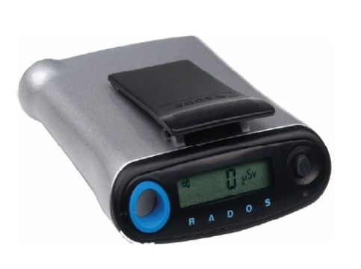
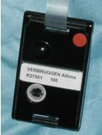

Radiation Investigation
Your education officer will demonstrate a radiation experiment using the scintillation counter and some radioactive sources.
What you will be investigating:
  - How radioactive are different household objects? Which of these sources should we choose for the experiments below and why?
And one of the following:
  - How does radioactivity change with distance from the source?
  - How does the thickness of a shielding material affect radiation penetration?
  - How do different types of shielding material affect radiation penetration?

Make some notes about the experiment that is performed in the spaces provided. After the videoconference you will need to write a report of this investigation using the headings of the scientific method.
Risk assessment:
Name of risk | Ways of managing named risk

Selecting a radioactive source:

Object | Radioactivity  (counts per second, cps) | Main radioactive element
Background
Potash
Uranium glass
Tungsten welding rods
Gas mantle
Radium watch
Uranium mineral (autunite)
Fiestaware plate

Which object would you select as your radioactive source for the radiation investigation? Justify your choice.
……………………………………………………………………………………………………………………………………………………………………………………………………………………………………………………………………………………………………………………………………………………………………………………………………………………………………………………………………………………………………………………………………………………………………………………………………………………………………………………
Results:

Further Notes

Use this space to take your own notes about areas of interest relevant to your depth study and to record any question you may have. The Education Officer will allocate 10 minutes at the end of the presentation for questions.

………………………………………………………………………………………………………………………………………………………………………………………………………………………………………………………………………………………………………………………………………………………………………………………………………………………………………………………………………
………………………………………………………………………………………………………………………………………………………………………………………………………………………………………………………………………………………………………………………………………………………………………………………………………………………………………………………………………
………………………………………………………………………………………………………………………………………………………………………………………………………………………………………………………………………………………………………………………………………………………………………………………………………………………………………………………………………
………………………………………………………………………………………………………………………………………………………………………………………………………………………………………………………………………………………………………………………………………………………………………………………………………………………………………………………………………
………………………………………………………………………………………………………………………………………………………………………………………………………………………………………………………………………………………………………………………………………………………………………………………………………………………………………………………………………
………………………………………………………………………………………………………………………………………………………………………………………………………………………………………………………………………………………………………………………………………………………………………………………………………………………………………………………………………
………………………………………………………………………………………………………………………………………………………………………………………………………………………………………………………………………………………………………………………………………………………………………………………………………………………………………………………………………
………………………………………………………………………………………………………………………………………………………………………………………………………………………………………………………………………………………………………………………………………………………………………………………………………………………………………………………………………

Post-Online Learning Activity 1: Modelling Fission

Models can be used to help scientists visualise things that they cannot actually see. They are used to describe, simplify, clarify or help form explanations. Models can be thought of as thinking tools to aid understanding. However, no model is perfect! So we need to consider the strengths and limitations of any model.

During the presentation, you explored the fission process taking place in the core of Australia’s one and only nuclear reactor, OPAL. At ANSTO, we use the neutrons produced in this process to make specific radioisotopes that have the properties we need to detect or treat diseases, such as cancer.

The information below provides a summary of the fission process taking place in OPAL.

The core of ANSTO’s OPAL reactor contains around 30 kg of uranium. 19.75% of this uranium is the fissionable Uranium-235, the rest is the other naturally occurring uranium isotope, Uranium-238, which absorbs neutrons and does not fission. There are about 100 different types of daughter nuclei that can be formed in the fission process. The diagram below shows one example of fission.

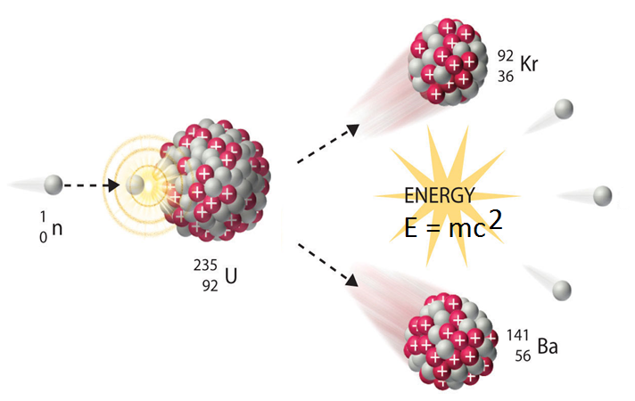
Thermal, low speed neutron
Two or three high energy, high speed neutrons are produced
You’re now going to examine an animation developed by ANSTO that models this fission process, to investigate the strengths and limitations of this animation model.
The ANSTO animation OPAL research reactor animation - YouTube can be found at https://www.youtube.com/watch?v=GooWJywwfgo&t=2s (animation can be viewed from 0.45 – 1.21)
Consider the information provided above, and during the ANSTO online learning session, , and use it to evaluate ANSTO’s fission animation model.
- What does this animation model show about the process of nuclear fission in our OPAL nuclear reactor?
…………………………………………………………………………………………………………………………………………………………………………………………………………………………………………………………………………………………………………………………
…………………………………………………………………………………………………………………………………………………………….
……………………………………………………………………………………………………………………………………………………………
…………………………………………………………………………………………………………………………………………………………….
- What are the limitations of this model of nuclear fission for our OPAL nuclear reactor? What is missing from or is not strictly correct in this model?
…………………………………………………………………………………………………………………………………………………………………………………………………………………………………………………………………………………………………………………………
…………………………………………………………………………………………………………………………………………………………….…………………………………………………………………………………………………………………………………………………………………………………………………………………………………………………………………………………………………………………………

- Does it simulate a controlled or uncontrolled fission reaction?
…………………………………………………………………………………………………………………………………………………………….
- Describe how the fission reaction is controlled in the OPAL reactor.
HINT: Watch the whole of the video to answer this question and question 5.
…………………………………………………………………………………………………………………………………………………………………………………………………………………………………………………………………………………………………………………………
…………………………………………………………………………………………………………………………………………………………….
…………………………………………………………………………………………………………………………………………………………….
- What is the role of the reflector vessel in OPAL in terms of the fission reaction?

…………………………………………………………………………………………………………………………………………………………………………………………………………………………………………………………………………………………………………………………
…………………………………………………………………………………………………………………………………………………………….
…………………………………………………………………………………………………………………………………………………………….
- Suggest an improvement you would make to the ANSTO animation model of fission to give people a better understanding of the fission process taking place in the OPAL reactor.

…………………………………………………………………………………………………………………………………………………………………………………………………………………………………………………………………………………………………………………………
…………………………………………………………………………………………………………………………………………………………….
…………………………………………………………………………………………………………………………………………………………….

Post-Online Learning Activity 2: Properties and uses of radioactive isotopes

At ANSTO, you will learn about the properties and uses of different natural and human-made radioisotopes. Refer to information about each isotope in our online radioisotope posters to complete the table below (https://www.ansto.gov.au/education/secondary/workbooks).
Isotope name | Number of protons | Number of neutrons | X  A  Z | Half-life | Balanced nuclear decay equation (including the types of radiation produced when it decays) | Use
Molybdenum-99

Technetium-99m

Iodine-131

Cobalt-60

Carbon-14

Uranium-235

Beryllium-10

Chlorine-36

Suggested videos
Viewing the following videos will also help you to get the most out of our online learning session (https://www.youtube.com/user/ANSTOVideos):

- Echidna: High speed powder diffractometer: This video shows how neutrons from inside the OPAL reactor are used in neutron diffraction instruments to study material structure at the atomic level.

- Radiocarbon dating on ANSTO’s VEGA accelerator: This video shows how VEGA particle accelerator is used to determine the age of artefacts and environmental samples up to 50,000 years old.

- Safely managing Australia’s radioactive waste: Nuclear research and medicine produced by ANSTO has benefited generations of Australians since the 1960s. With benefits, come responsibilities, and the by-products of nuclear research and medicine includes radioactive waste. ANSTO responsibly manages this waste in both the long and short term.

