PROGRAM
Real world applications of nuclear science: Nuclear medicine
Science teacher professional development session 3
Wednesday 28 October, 2020
Time | Details
4.00pm – 4.05pm | Official welcome and introductions
4.05pm – 4.15pm | Presentation 1: ‘Real world applications of nuclear science: Develop your own lesson’ course introduction
 | Speakers: Bridget Murphy and Tina Baradaran, ANSTO Discovery Centre
4.15pm – 4.25pm | Presentation 2: Introduction to nuclear medicine and radiopharmaceuticals at ANSTO
 | Presented by: Associate Professor Benjamin Fraser, Research Program Manager, Human Health Research Theme, ANSTO
4.25pm – 4.35pm | Presentation 3: Radioisotope development for medical applications
 | Presented by: Leena Hogan, Radioisotopes and Irradiations Manager, ANSTO
4.35pm – 4.45pm | Presentation 4: Australian innovation in nuclear medicine
 | Presented by: Dr Nigel Lengkeek, Radiometals Specialist, ANSTO
4.45pm – 5.00pm | Question and answer session
 | Chaired by: ANSTO.
5.05pm – 5.10pm | Refresh break
5.10pm – 5.25pm | Teaching nuclear medicines in the classroom
Presented by: Tina Baradaran and Julie Mulholland, ANSTO Discovery Centre

An introduction to resources developed by ANSTO’s education team and a discussion about how teachers can use them to build their own lesson on nuclear medicines. Instructions will also be given on the post TPD work required to be eligible to receive 7 NESA or TQI accredited hours.
5.25pm – 5.30pm | Evaluation and wrap up
 | Final questions and feedback

Speaker profiles:
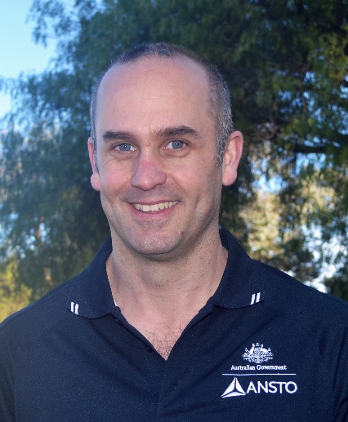 | Associate Professor Benjamin Fraser, Human Health Research Theme, ANSTO  Ben is a research lead and program manager in the Human Health Research Theme at ANSTO. He manages a synthetic chemistry laboratory and supervises staff members (scientific and technical), graduate students and post-doctoral researchers that are responsible for; 1) synthesizing new compounds for evaluation as new radio-tracers and radio-therapeutics, 2) undertaking in vitro and in vivo target affinity and metabolism studies and 3) undertaking radiolabelling optimisation studies. His research interests lie in the field of cancer diagnostics and treatment, brain imaging for mental disorders including depression and Alzheimer’s disease, and developing new radiolabelling techniques with the PET imaging isotope fluorine-18. Ben also teaches radiopharmaceutical science to undergraduates students at Monash University, USYD and UNSW.
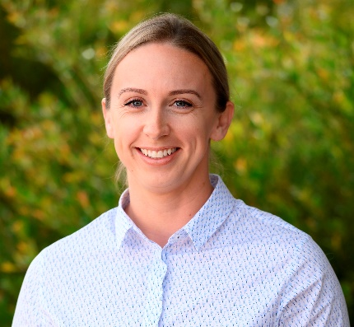 | Leena Hogan, Radioisotopes and Irradiations Manager, ANSTO  Leena Hogan is the Radioisotopes and Irradiations Manager for ANSTO Biosciences. Her research focuses on the development, separation, purification, and formulation of new radioisotopes for use in medical, environmental, agricultural and industrial applications. Recently, the radioisotope development team was responsible for Australia’s first production of scandium-47, a promising therapeutic radioisotope https://www.ansto.gov.au/news/potential-true-theranostic-agent-for-cancer-produced
Dr Nigel Lengkeek, ANSTO

Nigel is a senior radiochemist in ANSTO’s Biosciences Platform and leads the Radiotracer Development and Translation team. His team works with Australian and global companies, assisting them to translate their early stage radiopharmaceutical products to assets ready for clinical trials or routine clinical supply. An example of the work is highlighted here, https://www.ansto.gov.au/news/collaboration-develops-innovative-cancer-diagnostic-agent.
Bridget Murphy, Education Manager, has a background in biological science and science education and has worked in the ANSTO Education Team for ten years. Bridget is responsible for developing and delivering new programs for high school students and professional development for teachers.
Julie Mullholland, Education Officer, has a wealth of experience in science education, with a career teaching high school chemistry, physics and maths for nearly 30 years. Julie is instrumental in developing our data set resources for high school students.
Tina Baradaran, Education Officer, has a background in medical physics and as a secondary teacher. A recent member of the ANSTO Education Team, Tina uses her secondary expertise to assist the development of new education programs and professional development sessions for secondary teachers.

