ANSTO makes nuclear medicines
ANSTO makes more than 10,000 doses of nuclear medicine every week. Our nuclear medicines are used to diagnose and treat diseases like cancer. Our employees need to work quickly and safely to make and distribute these nuclear medicines.

Play: Play the Half-life Hero game (https://www.ansto.gov.au/education/apps) and practice making medicines as a reactor operator

Question: Why do ANSTO employees need to work quickly to make nuclear medicines?
____________________________________________________________
____________________________________________________________
____________________________________________________________
____________________________________________________________

Question: Do nuclear medicines usually have long or short half-lives? Why?
____________________________________________________________
____________________________________________________________
____________________________________________________________
ANSTO has Australia’s only nuclear reactor
 | ANSTO research reactor | Average power reactor
 | 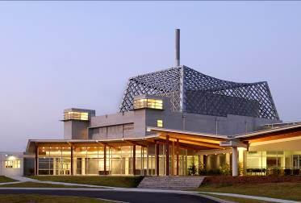 | 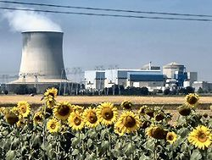
Power
Uranium
Temp.
Uses

Question: You simulated nuclear fission as a class using pieces of scrunched paper. What did the following represent in your simulation?
Students: ___________________________________________________
Pieces of paper: ______________________________________________

Question: What products of the fission reaction weren’t represented in this simulation?
_____________________________________________________________
ANSTO uses radiation safely
Large amounts of radiation can be dangerous, but we work safely with radiation by:
1. Reducing time spent near the radioactive source
2. Increasing distance from the radioactive source
3. Using shielding
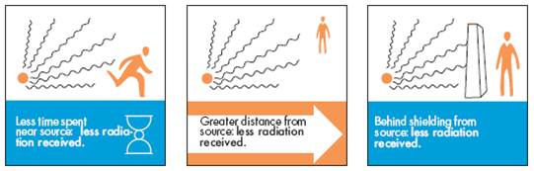
You will do an experiment to test how distance affects radiation count.
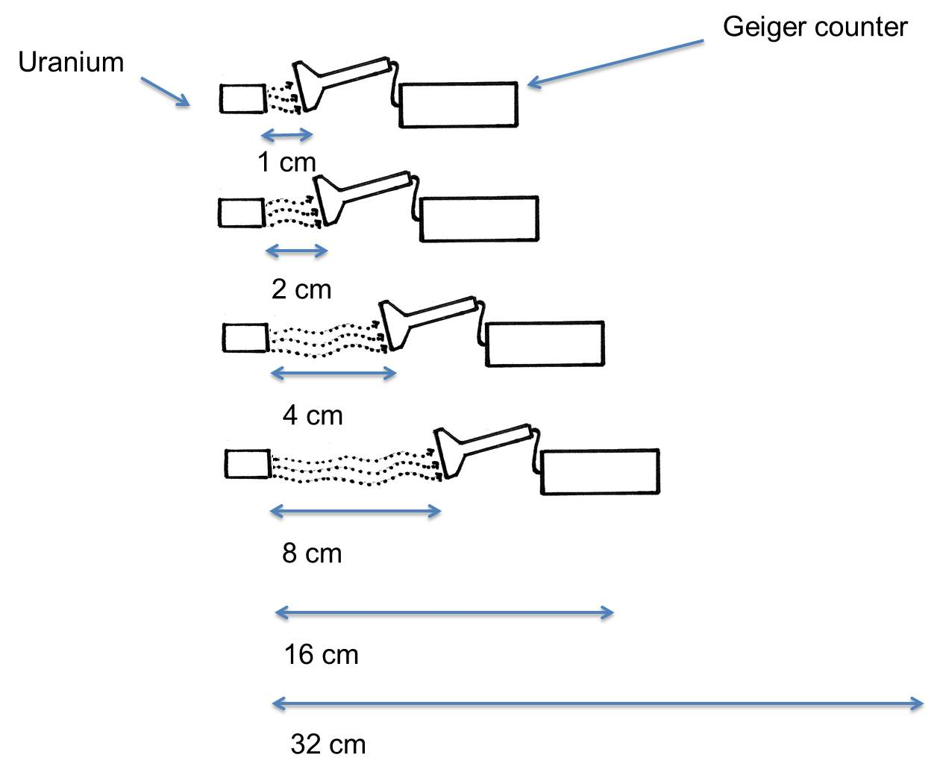

Prediction: As the distance from the radioactive source gets larger, I think the radiation count on the Geiger Counter will:
=
Stay the same
Decrease
Increase

Why? _______________________________________________________
____________________________________________________________

Write down the results of your experiment:

Distance from the source (cm) | Radiation (Counts per second)
1 cm
2 cm
4 cm
8 cm
16 cm
32 cm

Graph your results:
Distance from the source (cm)
2
4
6
8
10
12
14
16
18
20
22
24
26
28
30
32
0
2000
1500
1000
500
2500
Radioactivity (counts per second)

Conclusion:
Does your prediction match your results? Why?
____________________________________________________________
____________________________________________________________
Extension question: What shape is the graph? Is it a straight line or a curve? Why?

