Year 7-10 Science
Excursion workbook
Your visit to ANSTO
In the Discovery Centre, you will:
- Review atomic structure, isotopes and radioactivity
- View a demonstration of the use of a scintillation counter to measure radiation from low level sources.
- Investigate the periodic table and the properties and classification of elements
- Investigate medical applications of radioisotopes.

On site, you will visit:
- The OPAL (Open Pool Australian Lightwater) Research Reactor
- The Australian Centre for Neutron Scattering
- The Centre for Accelerator Science

Your visit to ANSTO
In the Discovery Centre, you will:
- Review atomic structure, isotopes and radioactivity
- Draw traces left by alpha particles, beta particles, protons and muons in the cloud chamber
- Use a scintillation counter to measure radiation from low level sources.
- Model radioactive decay and half-life
- Investigate medical applications of radioisotopes.

On site, you will visit:
- The OPAL (Open Pool Australian Lightwater) Research Reactor
- The Australian Centre for Neutron Scattering
- The Centre for Accelerator Science
- The ANSTO Nuclear Medicine Facility

Contents
Activity 1: Nuclear radiation and its uses in medicine 3
Activity 2: Why are some isotopes radioactive? 5
Activity 3: Investigating isotopes 6
Activity 4: It’s elementary! 7
Activity 5: Properties of α, β and γ radiation (during class presentation) 8
Activity 6: Measuring radiation (during class presentation)……………………………………………………………….9
Follow-up Activity: Radiocarbon dating 10

Hands-On Activities
- You will be allocated a group. Please remain with this group for each activity.
- Your group will be given 6 minutes to complete each activity.
- When the 6 minutes is up, an ANSTO Education officer will direct each group to their next activity. Do not move on until directed by an Education Officer.
Activity 1: Nuclear radiation and its uses in medicine
This activity has TWO parts. Allow 3 minutes for each part.
When an unstable nucleus decays, it gives off nuclear radiation. There are three main types of nuclear radiation – alpha (α), beta (β) and gamma (γ).

Read the information provided about alpha, beta and gamma radiation (4 mins)
- Using the large laminated table, place smaller cards into correct positions.
- Have your answers checked by a teacher
- Summarise the information from your answers into the table below, with any corrections.
Radiation type | Alpha | Beta | Gamma
Symbol

Energy or a particle?

Labelled diagram
Penetrating ability
(What types of materials stop it?)

The radiation from a diagnostic radioisotope needs to penetrate through the body and be detected by the scanner up to a metre away. Which radiation is most suitable for a medical radioisotope used for diagnostic purposes?
……………………………………………………………………………………………………………………………………………………………

Go to the touch screen labelled “Medical uses of nuclear energy” (3 min)
You’ll need to use the correct medical scans and radioisotopes to diagnose this patient, Fran.

Fran

What type of cancer did Fran have removed during surgery?
…………………………………………………………………………………………………………………

Circle the type of scan Fran needs to find out whether her surgery removed all the cancer:
Gamma scan CT scan SPECT scan MRI scan PET scan

Circle the name of the isotope Fran needs for this scan:
Molybdenum-99 Technetium-99m Iodine-123 Fluorine-18 Iodine-131

The scan showed that Fran’s surgery did not remove all the cancer. She will need treatment with another radioisotope that will attack any remaining cancer cells.

Circle the isotope Fran needs for her treatment and follow-up scan?
Molybdenum-99 Technetium-99m Iodine-123 Fluorine-18 Iodine-131

Activity 2: Why are some isotopes radioactive?
An isotope is radioactive if it has an unstable nucleus. An unstable nucleus will break down or “decay” over time to become more stable. An atom’s nucleus will be unstable if:
- it is too large and has too many protons and neutrons (all elements with more than 82 protons are radioactive)
- it contains too many neutrons for the number of protons
- it contains too few neutrons for the number of protons
- it has too much energy

Use the “Build an atom” simulator on the iPad to build the isotopes indicated in the table below.

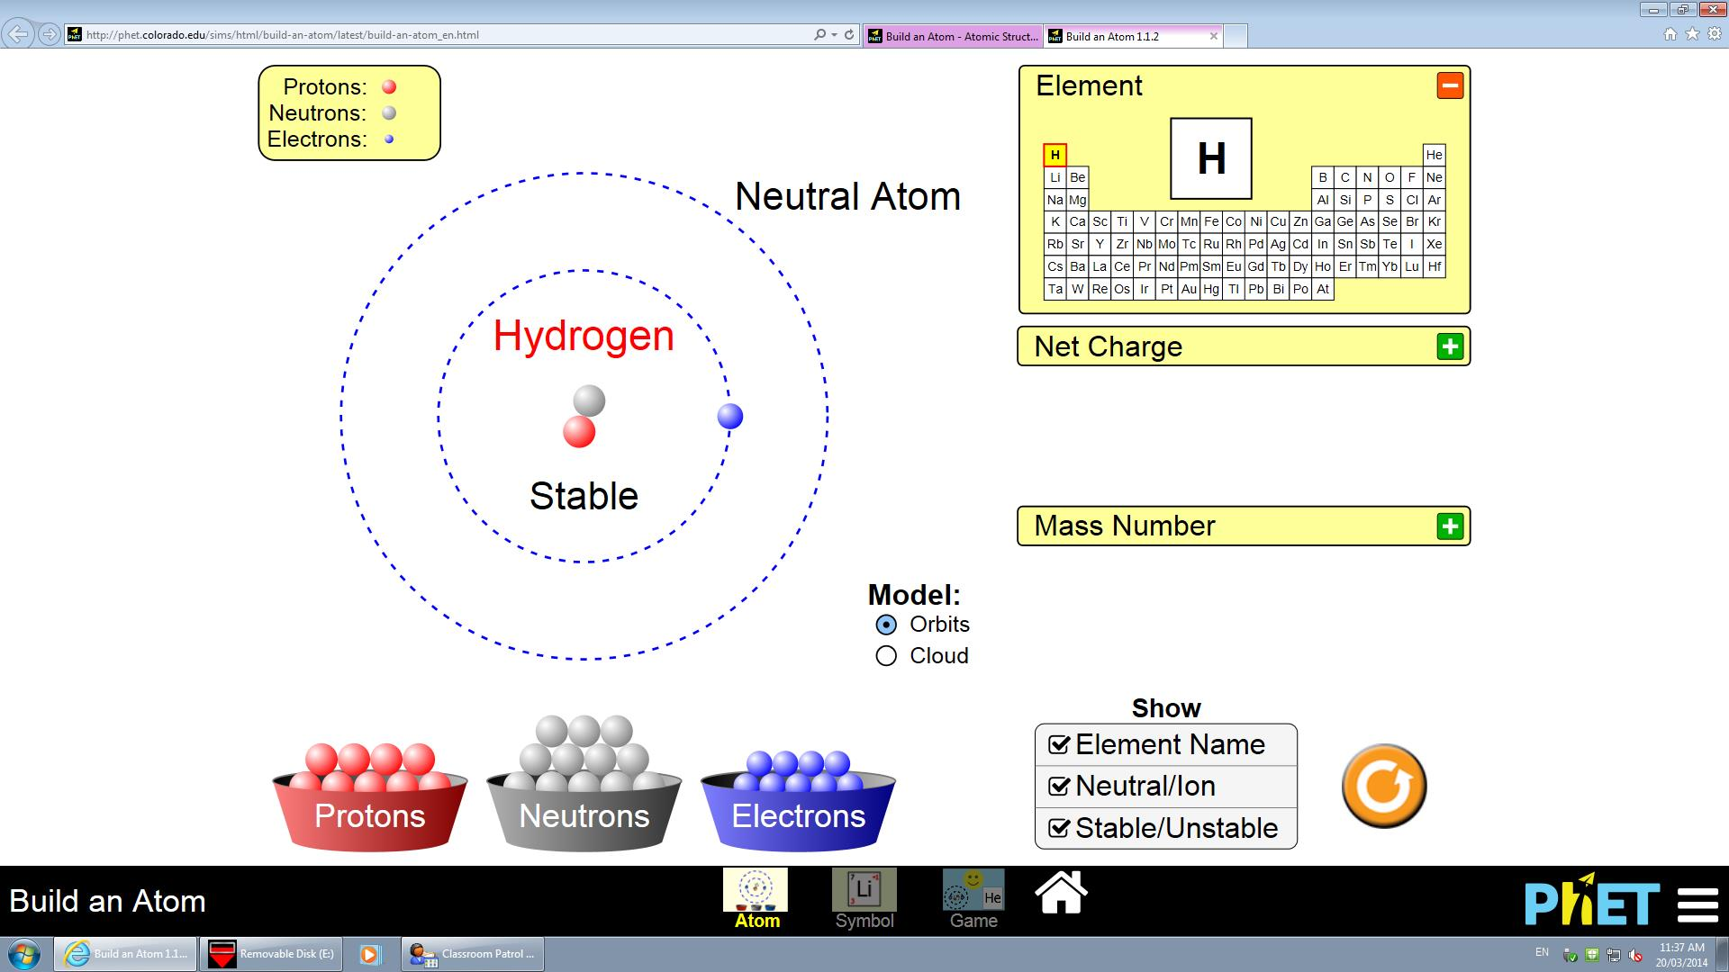
Make sure all of these have a tick √
Add protons to change the element
Add electrons to make a neutral atom
Add neutrons to make stable and unstable isotopes of an element

Isotope | Number of protons  Atomic number | Number of neutrons | Protons + neutrons  (mass number) | Stable or unstable?
hydrogen-1
hydrogen-2
hydrogen-3
carbon-12
carbon-13
carbon-14
fluorine-18
fluorine-19

Which isotopes in the table are unstable? Why are they unstable?
Isotope | Reason why it is unstable

Activity 3: Investigating isotopes
All matter is made of atoms. Atoms are composed of protons, neutrons and electrons.

Fill in the blanks with the following words:
Charge protons nucleus positive neutrons electrons
Protons have a ____________ charge and are found in the ____________ of an atom.
____________ have a negative charge and surround the nucleus. Neutrons have no
____________ and are found inside the nucleus.
Isotopes are atoms of an element that have the same number of ____________ but different numbers of ____________.

Use ANSTO’s XR app to bring the periodic table to life and complete the table below:
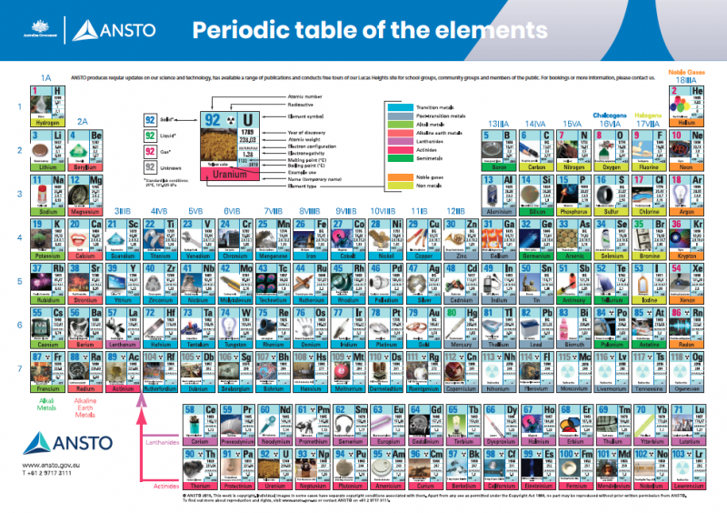

Element symbol | Key Isotope | Number of protons in isotope | Fun fact about isotope
U
Mo
Lu
Rn
K
C

Activity 4: It’s elementary!
You have been given 10 different elements, each enclosed in a clear plastic container. DO NOT OPEN the container or take the container from the plastic bag if present.
Place each element in its correct position on the periodic table provided.
- Classify each of the elements listed below as metal, non-metal or semi-metal. Use the colours from the key provided on the periodic table to help you.

Element symbol | Atomic number | Element name | Classification  metal/ non-metal/ semi-metal
Mo | 42
C | 6
Se | 34
Te | 52
Ga | 31
Si | 14

- (a) Place a magnet on top of each of the clear plastic element containers and observe what happens. Which of these elements are attracted to the magnet?
………………………………………………………………………………………………………………………………………………………
(b) Name the other element NOT PROVIDED in the containers that is attracted to a magnet.
………………………………………………………………………………………………………………………………………………………

- Which THREE elements belong to the same group (that is, are in the same vertical column) of the periodic table? What do the atoms of these elements have in common?
………………………………………………………………………………………………………………………………………………………
………………………………………………………………………………………………………………………………………………………

- The ANSTO periodic table shows one use of each element.
From the elements you have been given, which of these elements is commonly used for treating dandruff when present as its sulfide compound? ………………………………………………………………………………………………………………………………………………………

Activity 5: Properties of α, β and γ radiation (during class presentation)
A special type of Geiger counter called a scintillation counter can be used to investigate the properties of α, β and γ radiation. In this activity we will investigate what type of radiation is being emitted from the sources by using different types of shielding.

Fill out the table below recording the radioactivity of each source with no cover, paper, aluminium and lead and use this to determine what type of radiation is being emitted by each source.

Background reading: _____
Source | Radioactivity (counts per second)
 | No cover | Paper | Aluminium | Lead
A
B
C

What type of radiation is being emitted by Source A? Why do you think this?
…………………………………………………………………………………………………………………………......................................................................................................................................................................................................................................................................................................................................................

What type of radiation is being emitted by Source B? Why do you think this?
…………………………………………………………………………………………………………………………......................................................................................................................................................................................................................................................................................................................................................

What type of radiation is being emitted by Source C? Why do you think this?
…………………………………………………………………………………………………………………………......................................................................................................................................................................................................................................................................................................................................................

Activity 6: Measuring radiation (during class presentation)
A special type of Geiger counter called a scintillation counter can be used to measure radioactivity. In this activity the radioactivity of a variety of different objects will be investigated.

Fill out the table below stating the radioactivity of each object and what element makes that object radioactive.

Radiation source | Radioactivity (counts per second) | What makes this radioactive?
Background radiation

Potassium sulfate fertiliser
Uranium glass
Thorium gas mantle
Fiestaware plate

How does the reading on the scintillation counter differ when the detector is close to the radioactive source compared to when it is further away?

…………………………………………………………………………………………………………………………......................................................................................................................................................................................................................................................................................................................................................

Follow-up activity: Radiocarbon dating
ANSTO scientists use radiocarbon dating to determine the age of ancient artefacts and to study climate change.
This dating method works by measuring the ratio of the different isotopes of carbon in a sample using a particle accelerator.
There are three main isotopes of carbon on earth.
- Carbon-12 isotope (99% of all carbon on earth)
- Carbon-13 (almost 1% of all carbon on earth)
- Carbon-14 (trace amounts only)

Use the information above and the words provided to fill in the blanks:
seven (7) trace stable most common radioactive eight (8) nucleus six (6)
Carbon-12 is the ________ __________ carbon isotope. It is __________ and contains 6 protons and 6 neutrons in its ____________. Carbon-13 makes up almost 1% of all carbon on earth. It is also stable and contains 6 protons and ______ neutrons in its nucleus. Carbon-14 is found in ___________ amounts. It is unstable and ___________________, and its nucleus contains ______ protons and _____ neutrons.

Draw an atom of carbon-12 and an atom of carbon-14 using the key supplied to show the number of protons, neutrons and electrons.
-
-
-

Proton Neutron Electron
+
Carbon-14
Carbon-12
Nucleus
Nucleus

Radiocarbon dating (cont.)
Living things contain carbon-14 and carbon-12 in a ratio that is the same as in the atmosphere at the time. When the organism dies, the ratio of carbon-14 to carbon-12 decreases, as carbon-14 decays and is no longer incorporated into the organism.
Using carbon dating, scientists can calculate how much carbon-14 decay has occurred by measuring the ratio of carbon-14 to all carbon atoms in the sample. The extent of carbon-14 decay will reveal the age of the sample. The half-life of carbon-14 is 5730 years and a graph of carbon-14 is below:

For example, a scientist calculates that an artefact contains only 50% of the original amount of carbon-14 it contained when it died. The scientist would use a graph like the one above to calculate that the artefact is approximately 5730 years old.

Radiocarbon dating (cont.)
Use the graph of carbon-14 decay on the previous page to solve these real-life science puzzles:
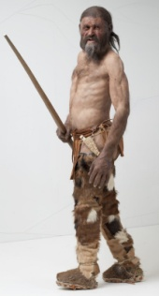
- In 1991, hikers in Northern Italy found the perfectly preserved frozen body of a prehistoric man. Scientists named him Ötzi. Samples of his bones, hair, boots and clothes were carbon dated and revealed that Ötzi lived almost 5500 years ago.

What percentage of the original carbon-14 in Ötzi’s body was remaining in 1991?
…………………………………………………………………………………………………………………………...

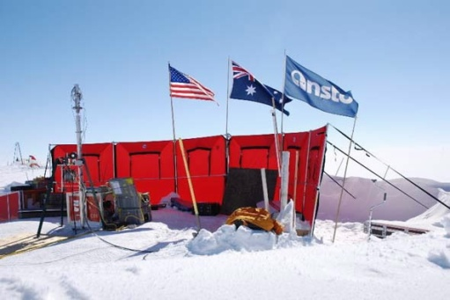
- Climate scientists, including Dr Andrew Smith at ANSTO, drill deep into Antarctic ice to find out more about the gases in our atmosphere thousands of years ago. As layers of snow and ice form year after year, air bubbles become trapped deep in the ice and serve as a frozen historical record of the gases in our atmosphere over time.
The eldest ice core from Antarctica so far was 3200m deep. Scientists dated the gases in the air bubbles at the bottom of this ice core and found that only 29% of the original carbon-14 remained.

How long ago were these air bubbles trapped in the ice?
…………………………………………………………………………………………………………………………...out 10,000 years ago
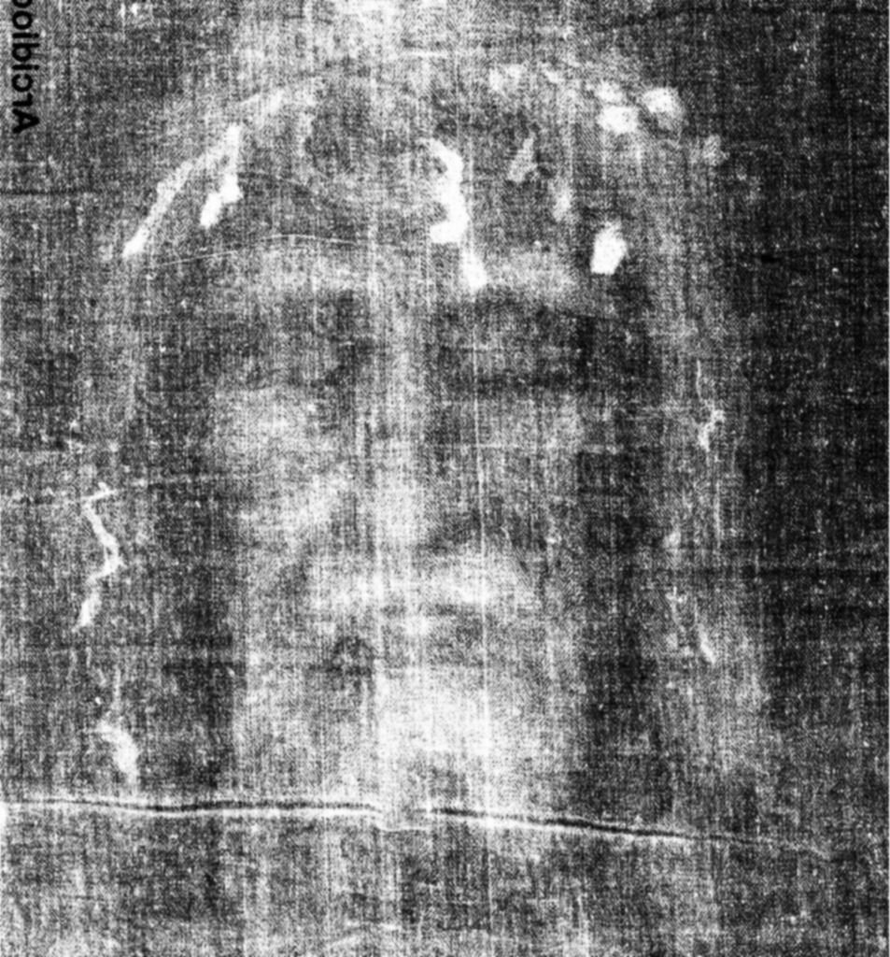
- The authenticity of the Shroud of Turin had long been debated. The shroud is said to be a piece of cloth that was used to wrap the body of Jesus after he was crucified. In 1988, scientists received permission from the Vatican to remove small samples for carbon dating. Three different laboratories around the world analysed the samples. All three laboratories came to a similar conclusion: The shroud had lost about 8 percent of its carbon- 14 atoms to radioactive decay.

What is the approximate date of origin of the Shroud of Turin?
(Note: Despite these and other scientific investigations, the origin and date of the Shroud of Turin remains a subject of controversy.)
…………………………………………………………………………………………………………………………...

- Carbon dating is most useful for determining the age of objects up to about 50,000 years old.

Why is carbon dating less accurate for objects older than this?

…………………………………………………………………………………………………………………………......................................................................................................................................................................................................................................................................................................................................................

